Visual Programming

Project Report

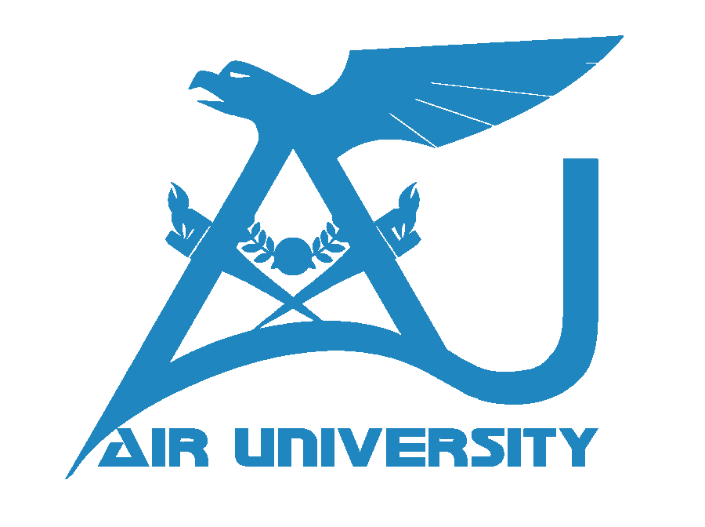

Submitted by: Muzaffar Iqbal

Roll no. : 203130

Submitted to : Sir Saad-Ur-Rehman

Date: 05-01-2023

Project name :
Fumigation System

My project is fumigation System which contain the admin and employees members.which has following forms;

Login:
A login form is a common feature on websites and applications that allows users to access restricted content or features by entering their login credentials (e.g., username and password).
Determine the requirements for the login form, including the type of information that the user will need to provide in order to log in (e.g., username, password).

Design the layout and appearance of the login form. This may involve creating a graphical user interface (GUI)
Implement the login form's functionality. This will involve writing code to handle user input, verify the entered login credentials, and either grant or deny access to the user based on the results of the verification process. This may involve storing the login credentials in a database or file and comparing the entered credentials to those stored in the database.

Test the login form to ensure that it is functioning properly and that all required input fields are working as intended.
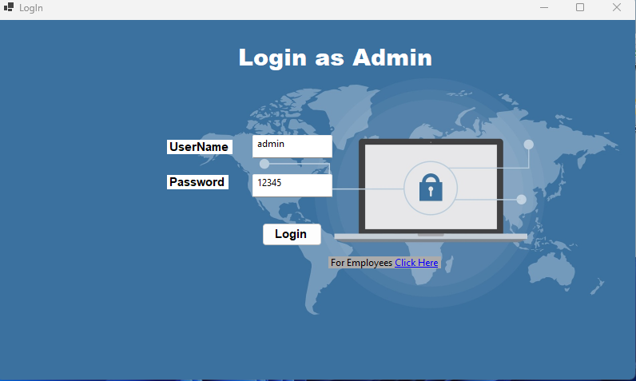
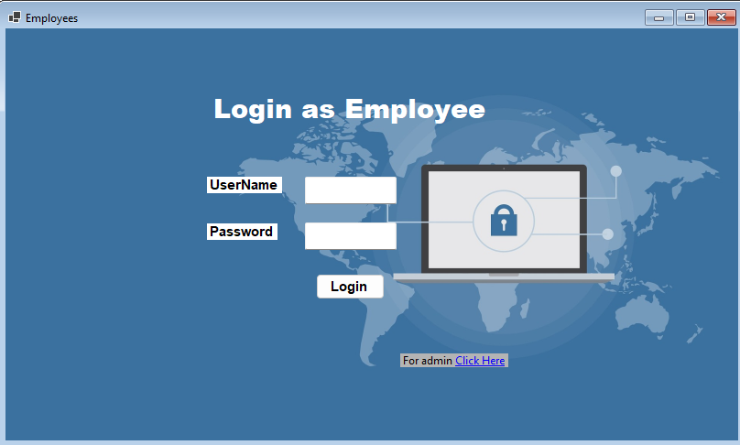
An admin dashboard is a user interface that provides administrators with access to various tools and features for managing and monitoring a website or application. Here are some common features that an admin dashboard might include:

A user management system for adding, deleting, and modifying user accounts
A content management system for creating, editing, and publishing content on the website or application
Performance and analytics tools for tracking website traffic, user engagement, and other metrics
System management tools for configuring server settings, managing databases, and performing other technical tasks
Security and permission controls for defining the roles and responsibilities of different users and groups.
There are three shows up to admin shows the requests to admin and the admin can approve these requests,maintain the employees and all the data.
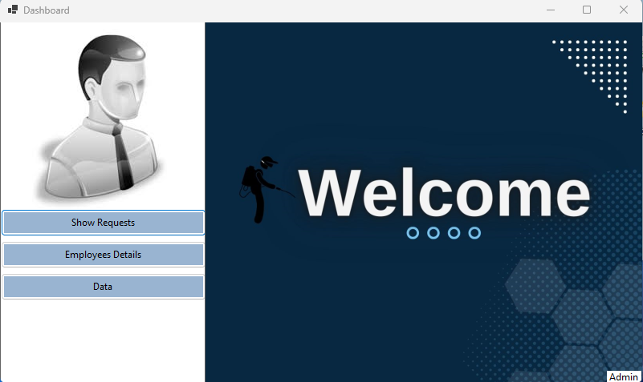

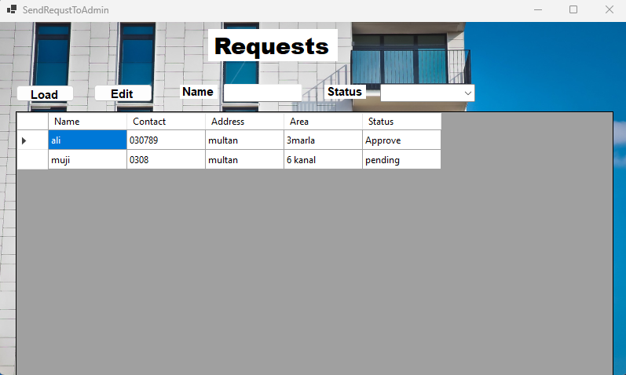

Employee dashboard:
An employee dashboard is a user interface that provides employees with access to various tools and information related to their work. Here are some common features that an employee dashboard might include:

Personalized information and updates, such as upcoming deadlines or tasks assigned to the employee.
Here employees can send the requests of customers to admin for approval and see the status.
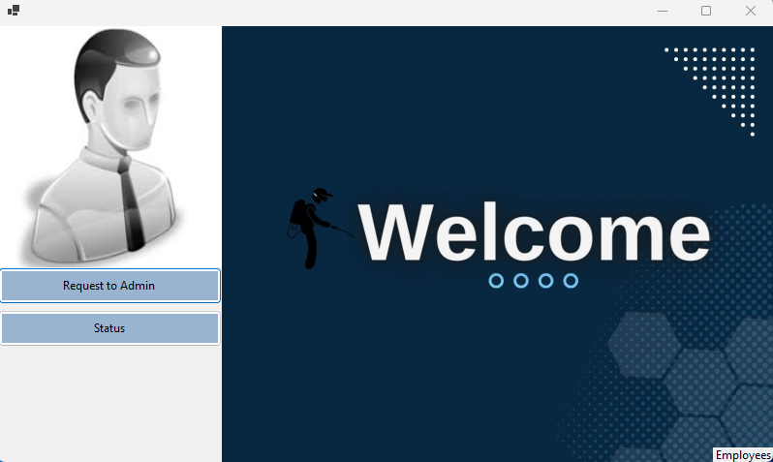
Employees can collect all the information from the customer

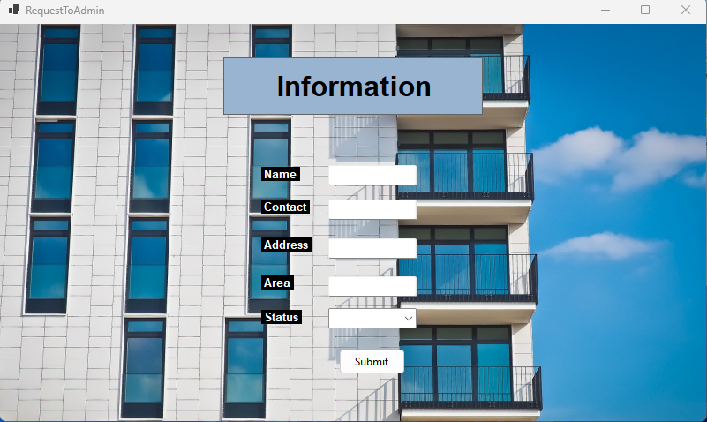
Here employees can see the status of customer requests.

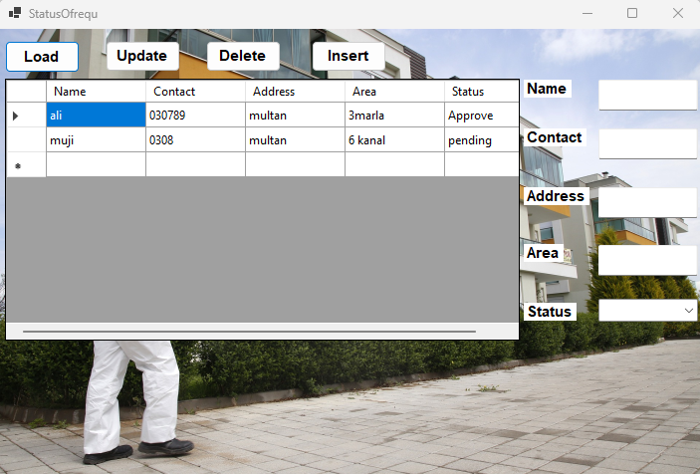
Here is all the data admin can see

